Strength and weakness of my weather app

* The code is both good and bad as far as both functionality and design are concerned. On the positive side, the code correctly fetches weather information from an external API and dynamically updates the webpage with appropriate data including city name, temperature, weather description, humidity, and weather icon. The offline support integration is a nice touch, as it utilizes local Storage to store weather data when offline, allowing the app to be usable without an internet connection. The PHP end of the code is also sound, creating a database and a table to store the weather data of cities so that new weather data is inserted and retrieved effectively when the weather of a city is requested. This design provides the same data fetching and seamless user experience without genuine real-time API calls. In addition to this, the application enables a dynamic, personalized experience by searching for other cities and manipulating the DOM accordingly as per the fetched data.

In spite of this, the code has serious vulnerabilities. Hardcoding an API key is a security vulnerability, as exposing API keys in code could result in abuse or unauthorized usage. There is also no open error handling in the JavaScript in case the API request itself fails or the response is not in the correct format, which could cause problems if the server is unavailable or the data structure is modified. The PHP code would also benefit from more robust error checking for database operations, i.e., if the insertions or queries succeed. Lastly, there is no type of timestamp or cache mechanism in the database schema, which would make handling stale data or data fetch optimization harder, particularly if the weather fluctuates rapidly.

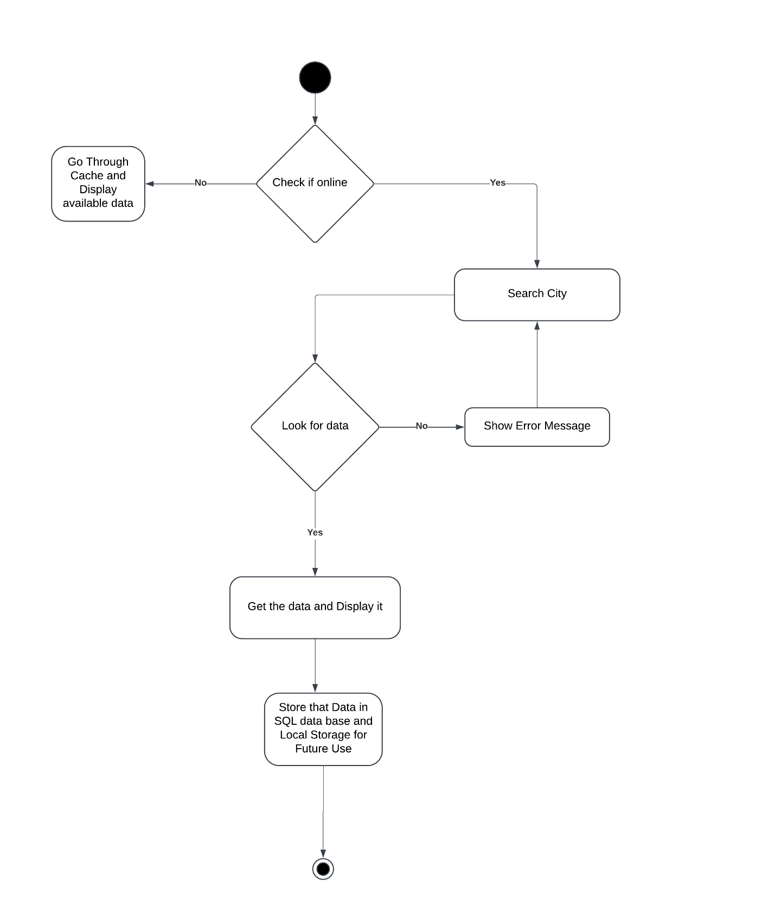

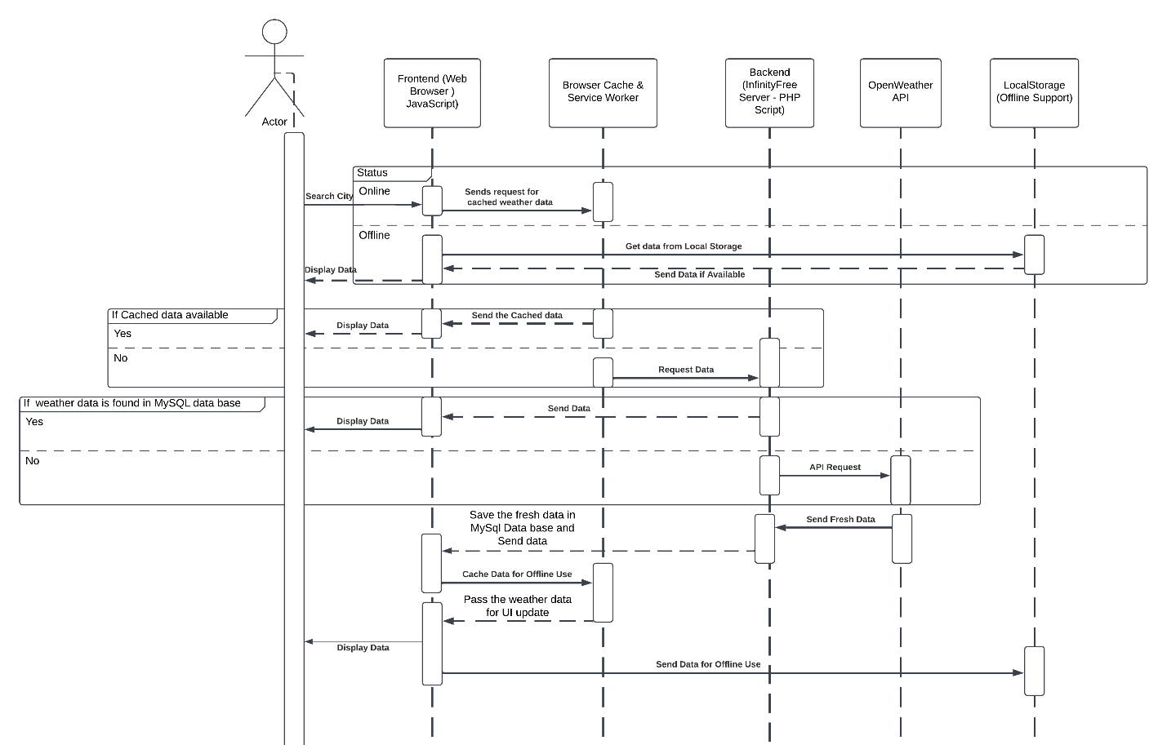

Link :

https://jayagko.infinityfreeapp.com/index.html

